**Mark Of The Ninja Research:**

When playing *Klei Entertainment’s* ‘Mark of The Ninja’ there is a good use of a grapple hook in the game where the player can only grapple to certain surfaces marked with a symbol, this allowed players easier mobility along with different approaches to situations so that they do not all end in combat and/or death since the aim of the game is to avoid hand to hand combat at all costs and try to assassinate enemies from the shadows instead.

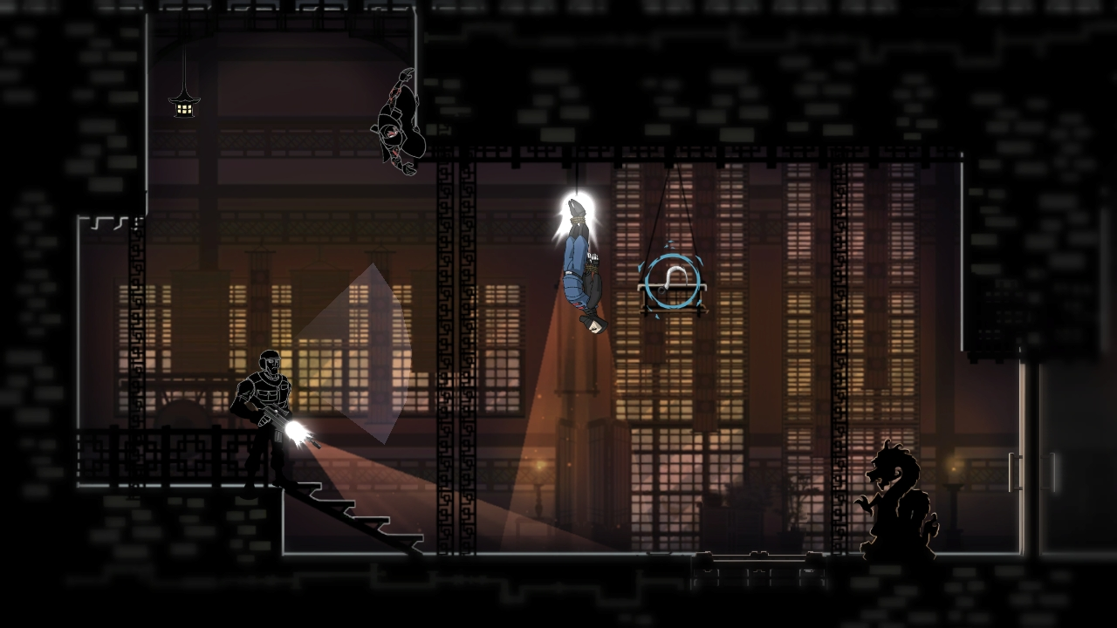

Figure : Example of grapple symbol on applicable object

This stealth mechanic mixed with the vertical layout of the levels is similar to our game idea of having a platformer with stealth mechanics that will reward players for avoiding combat and instead going around the enemy and hiding from them.

Another way that players can use this grapple mechanic is by using it to lower themselves from the ceiling and attacking enemies that way if they’re playing the game violently.

The way that this grappling hook works is that it doesn’t have any physics attached to it so that the character doesn’t swing when attached to an object, it instead just pulls the player from where they are directly to the grappling point, this would fit perfectly inside of our game and inside of our team’s scope since it’s a simple movement mechanic that would still work well when mixed into the stealth aspect of the game.

When looking into the enemy AI of the game there is a FOV cone that is infront of the enemy characters; showing how far ahead of themselves they can look when in the dark, this means that player knows where to avoid as they’re working their way around the enemy and doesn’t feel as though it’s unfair.